◆ Platform User Guide — Subject Supervisor ◆
For: the subject supervisor in educational supervision
Your scope is a subject, not a school: you see your subject's lessons in the complex you visit each day, you observe them and approve their result. The subject and day filters narrow the schedule in a second.
Before you start — four things that concern everyone
1. Open the link — https://ahseyam.github.io/unified-lesson/
2. Switch to English — the EN button, top right
3. Choose your role — one card per role
4. Enter your staff number — you are identified by it, not by your name

• Open the link: It runs on phone, laptop and tablet with nothing to install. Bookmark it — it is your single reference; do not rely on a copy someone sends you, or you will be working from yesterday's data.
• Switch to English: Press it once and the choice is remembered on your device. Arabic is the default for everyone, so nothing changes for your Arabic-speaking colleagues. You may enter your own text in English or Arabic — both are kept as typed.
• Choose your role: Each role sees only what concerns it: its own buttons, screens and reports. You will not see what is not yours, and you cannot press a button that destroys someone else's work.
• Enter your staff number: Names repeat and are spelled in different ways, so the same person appears twice in the reports. If your number is on the roster, your name and subject are filled in for you.
❖ Step by step — with pictures every screenshot is taken from the platform itself, not drawn or imagined
1 Sign in and choose your subject
• Choose the “Subject supervisor” card, then your subject — your scope is known from it.
• If your number is on the roster, your subject is filled in for you.
⛔ The subject is a taught subject, not a university qualification: someone qualified in chemistry appears under “Science”.

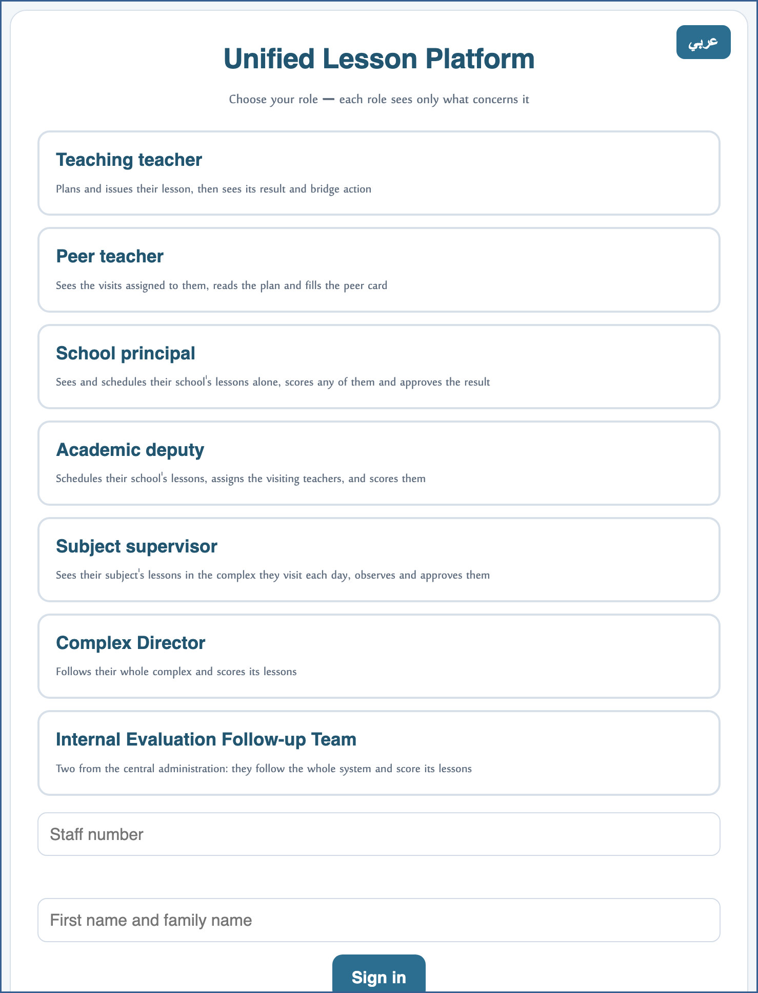
A live screenshot of the platform itself
2 Narrow the schedule by subject and day
• The “Subject you visit” and “Day” filters sit above the schedule.
• The “My visit today” button sets the week, the day and the complex from today's date in one press.
• Together they bring the rows down from hundreds to your lessons alone.
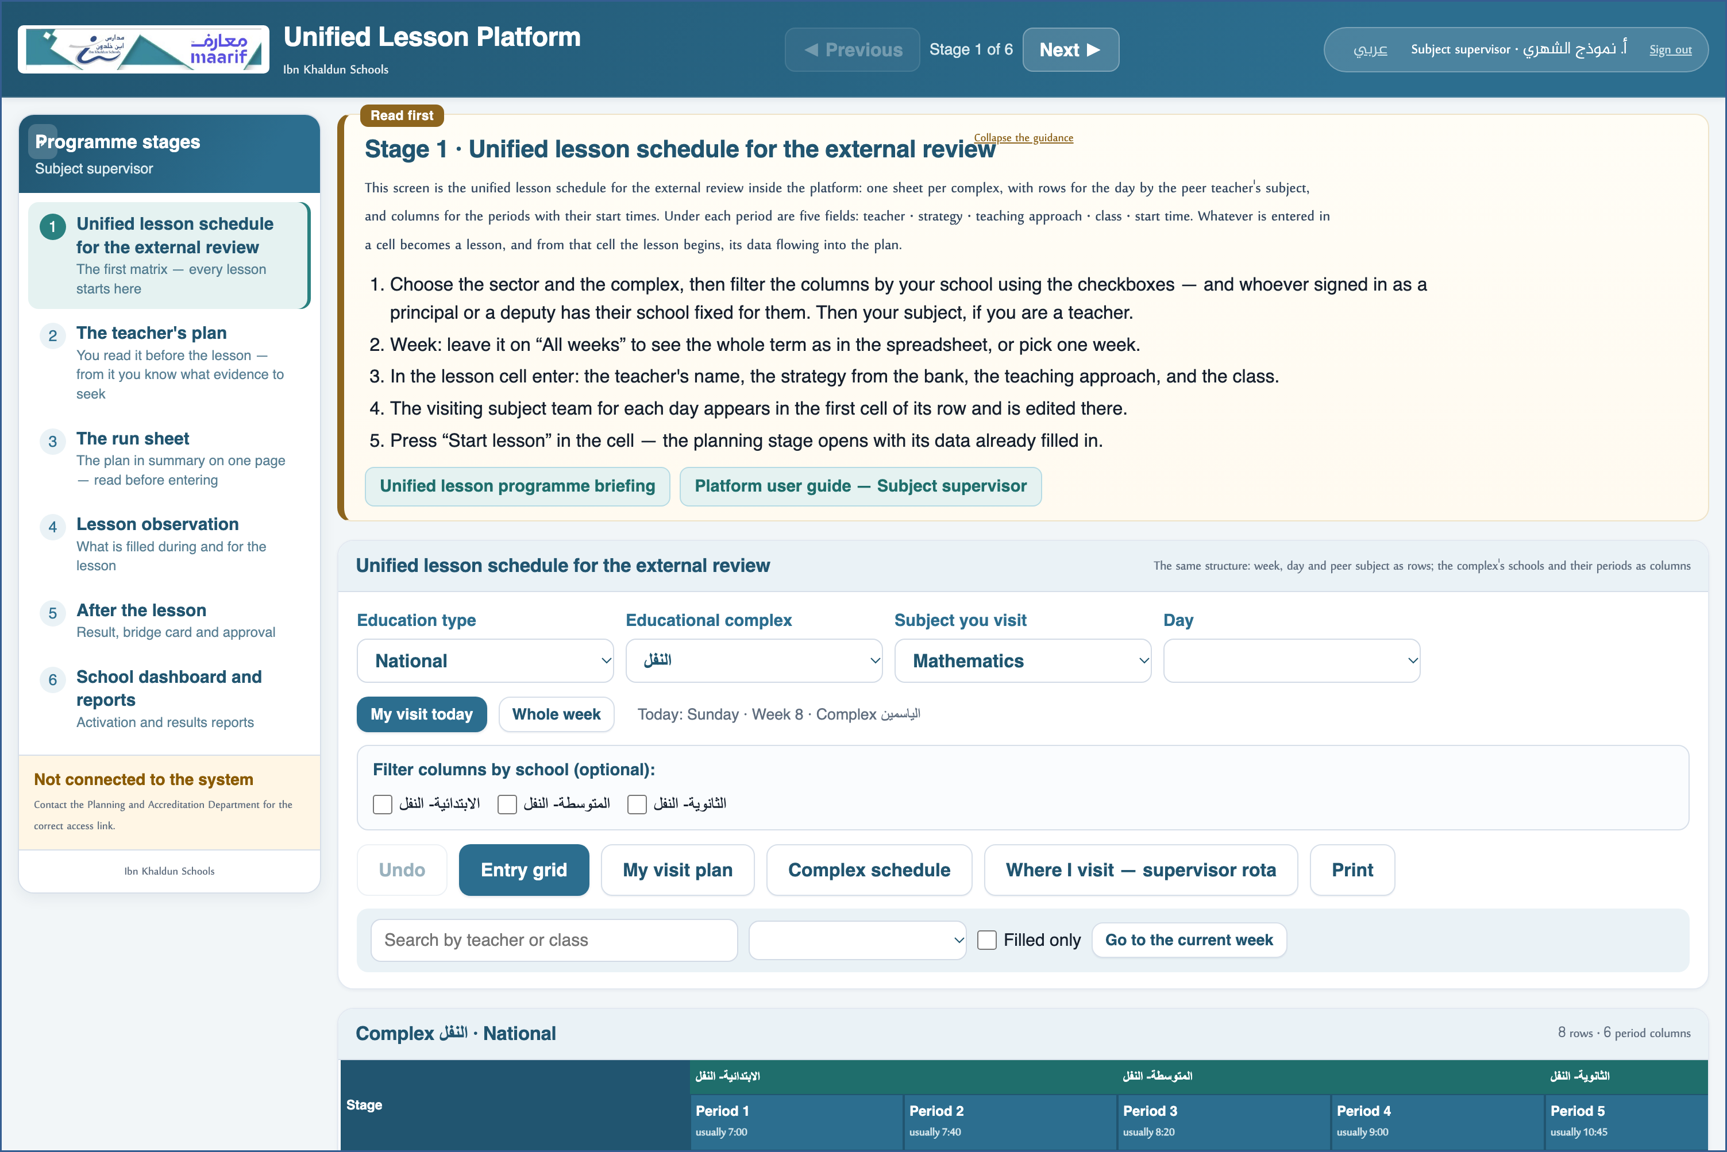
A live screenshot of the platform itself
3 Review your week's plan
• “My visit plan”: the days of the week and your subject's lessons in each one.
• The state of each plan comes with it — so you know before you set out.
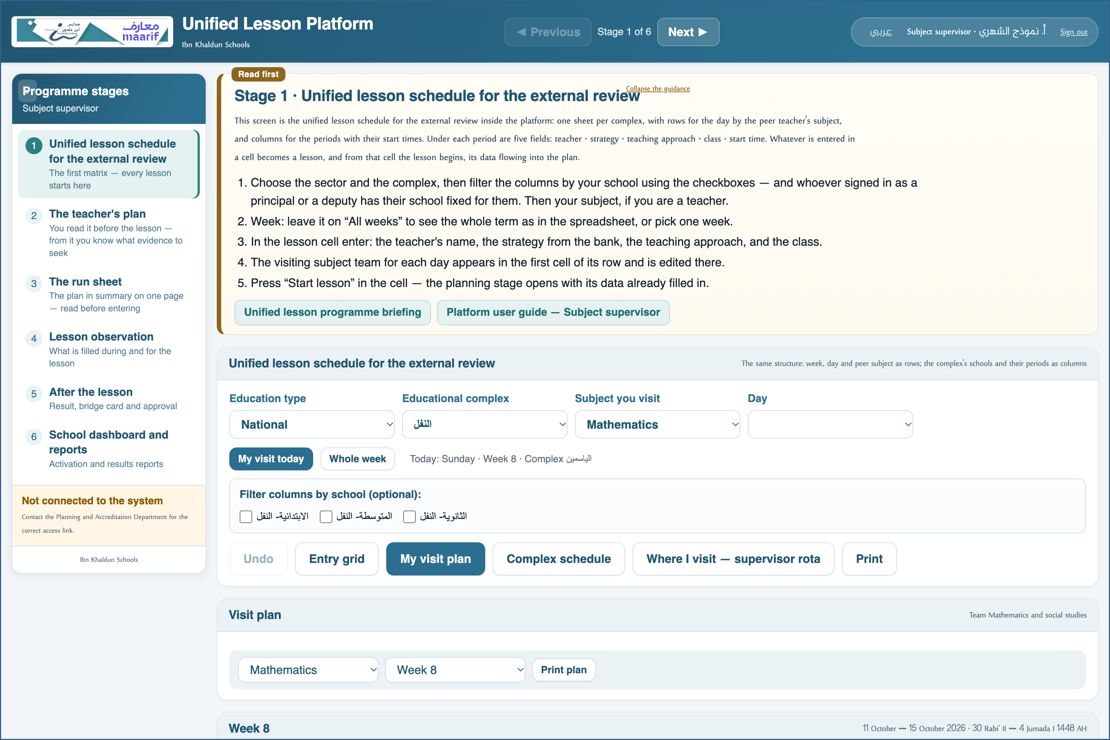
A live screenshot of the platform itself
4 Where I visit — supervisor rota
• Which complex your subject team goes to on each day of each week.
• The order is your actual day: primary first, then intermediate, then secondary, by period times.
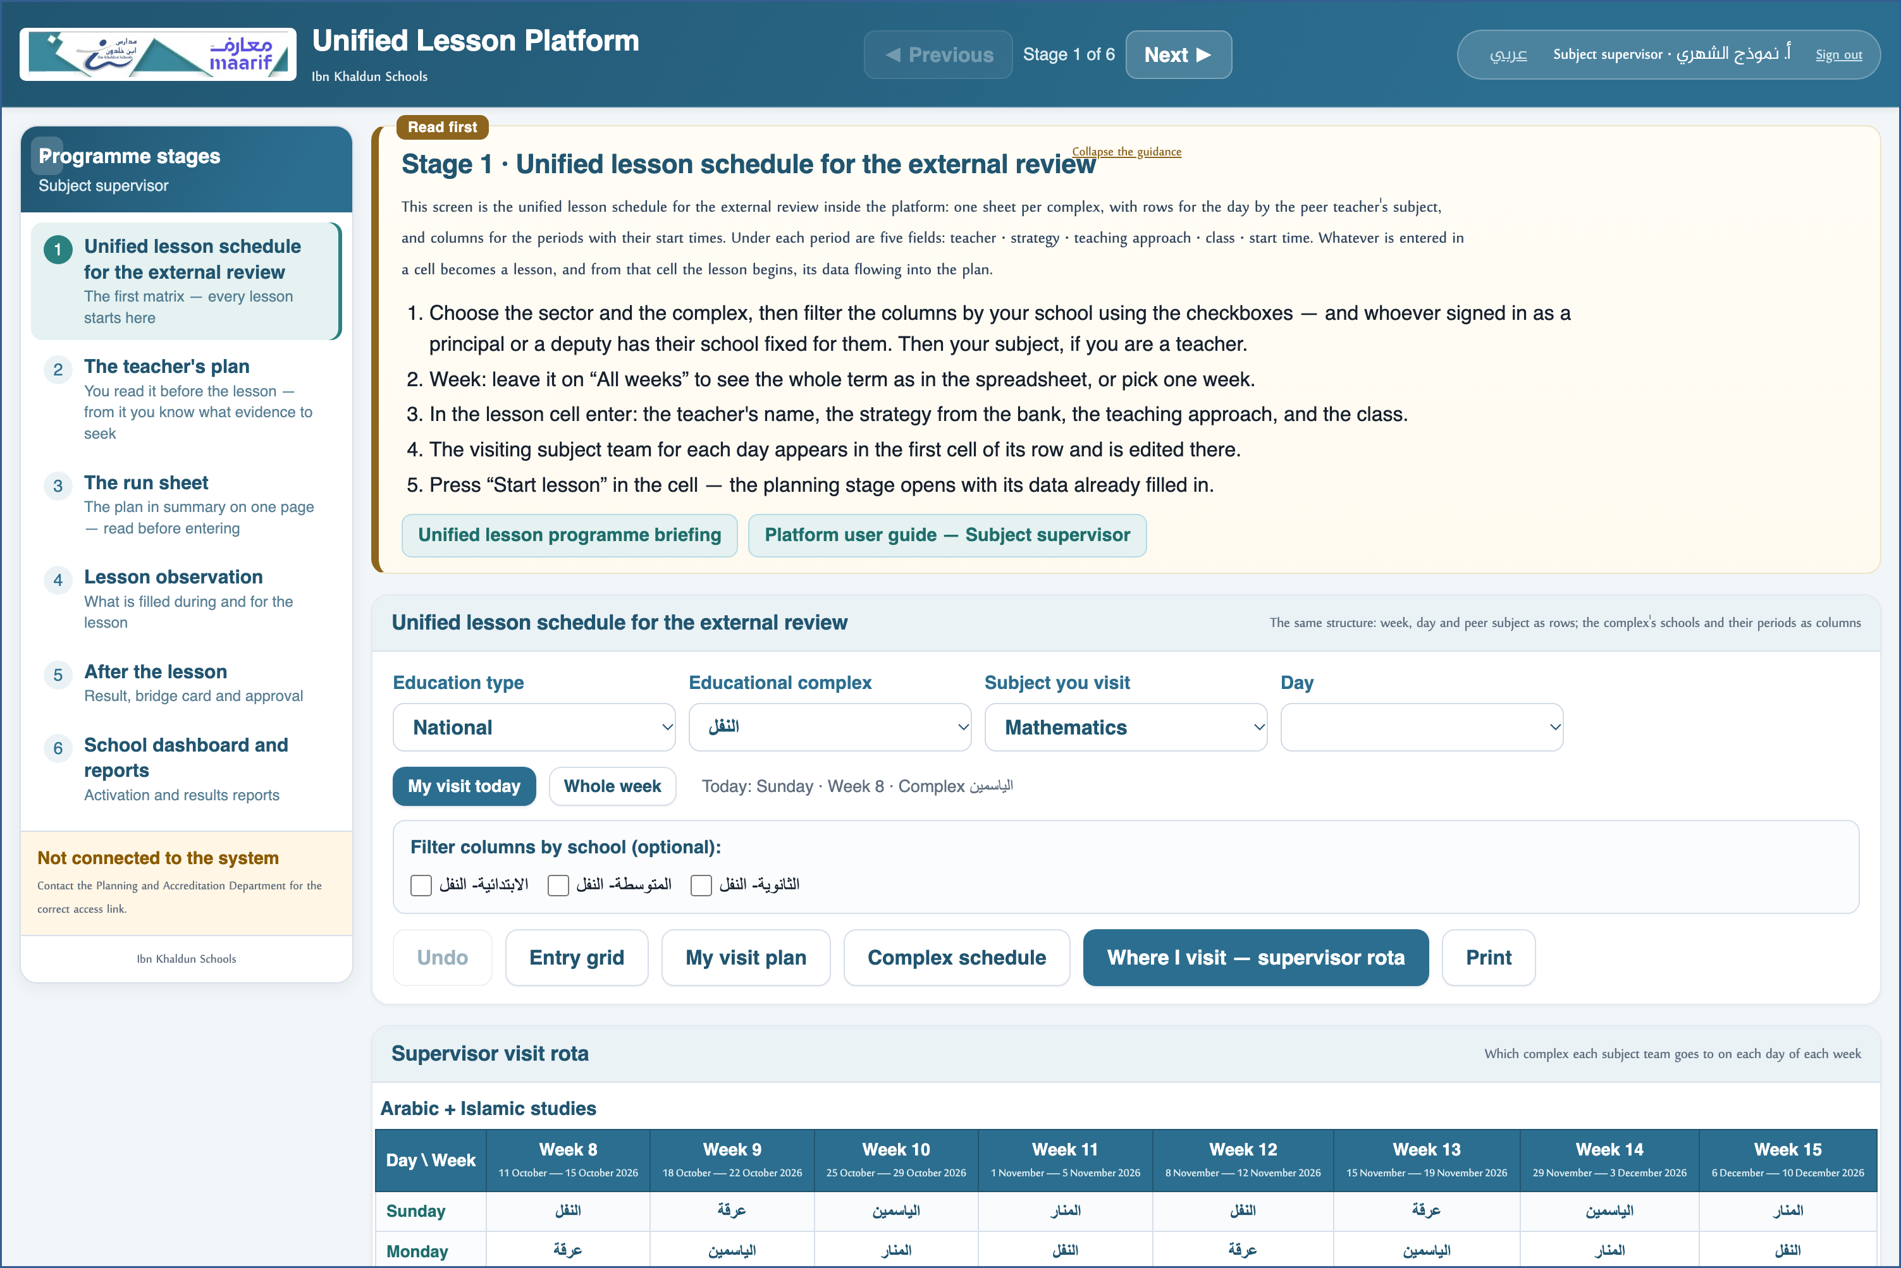
A live screenshot of the platform itself
5 Observe and approve
• Your capacity, “Subject supervisor”, is filled from your role automatically.
• Complete the rubric and the strategy card, then approve the result once the observations are complete.
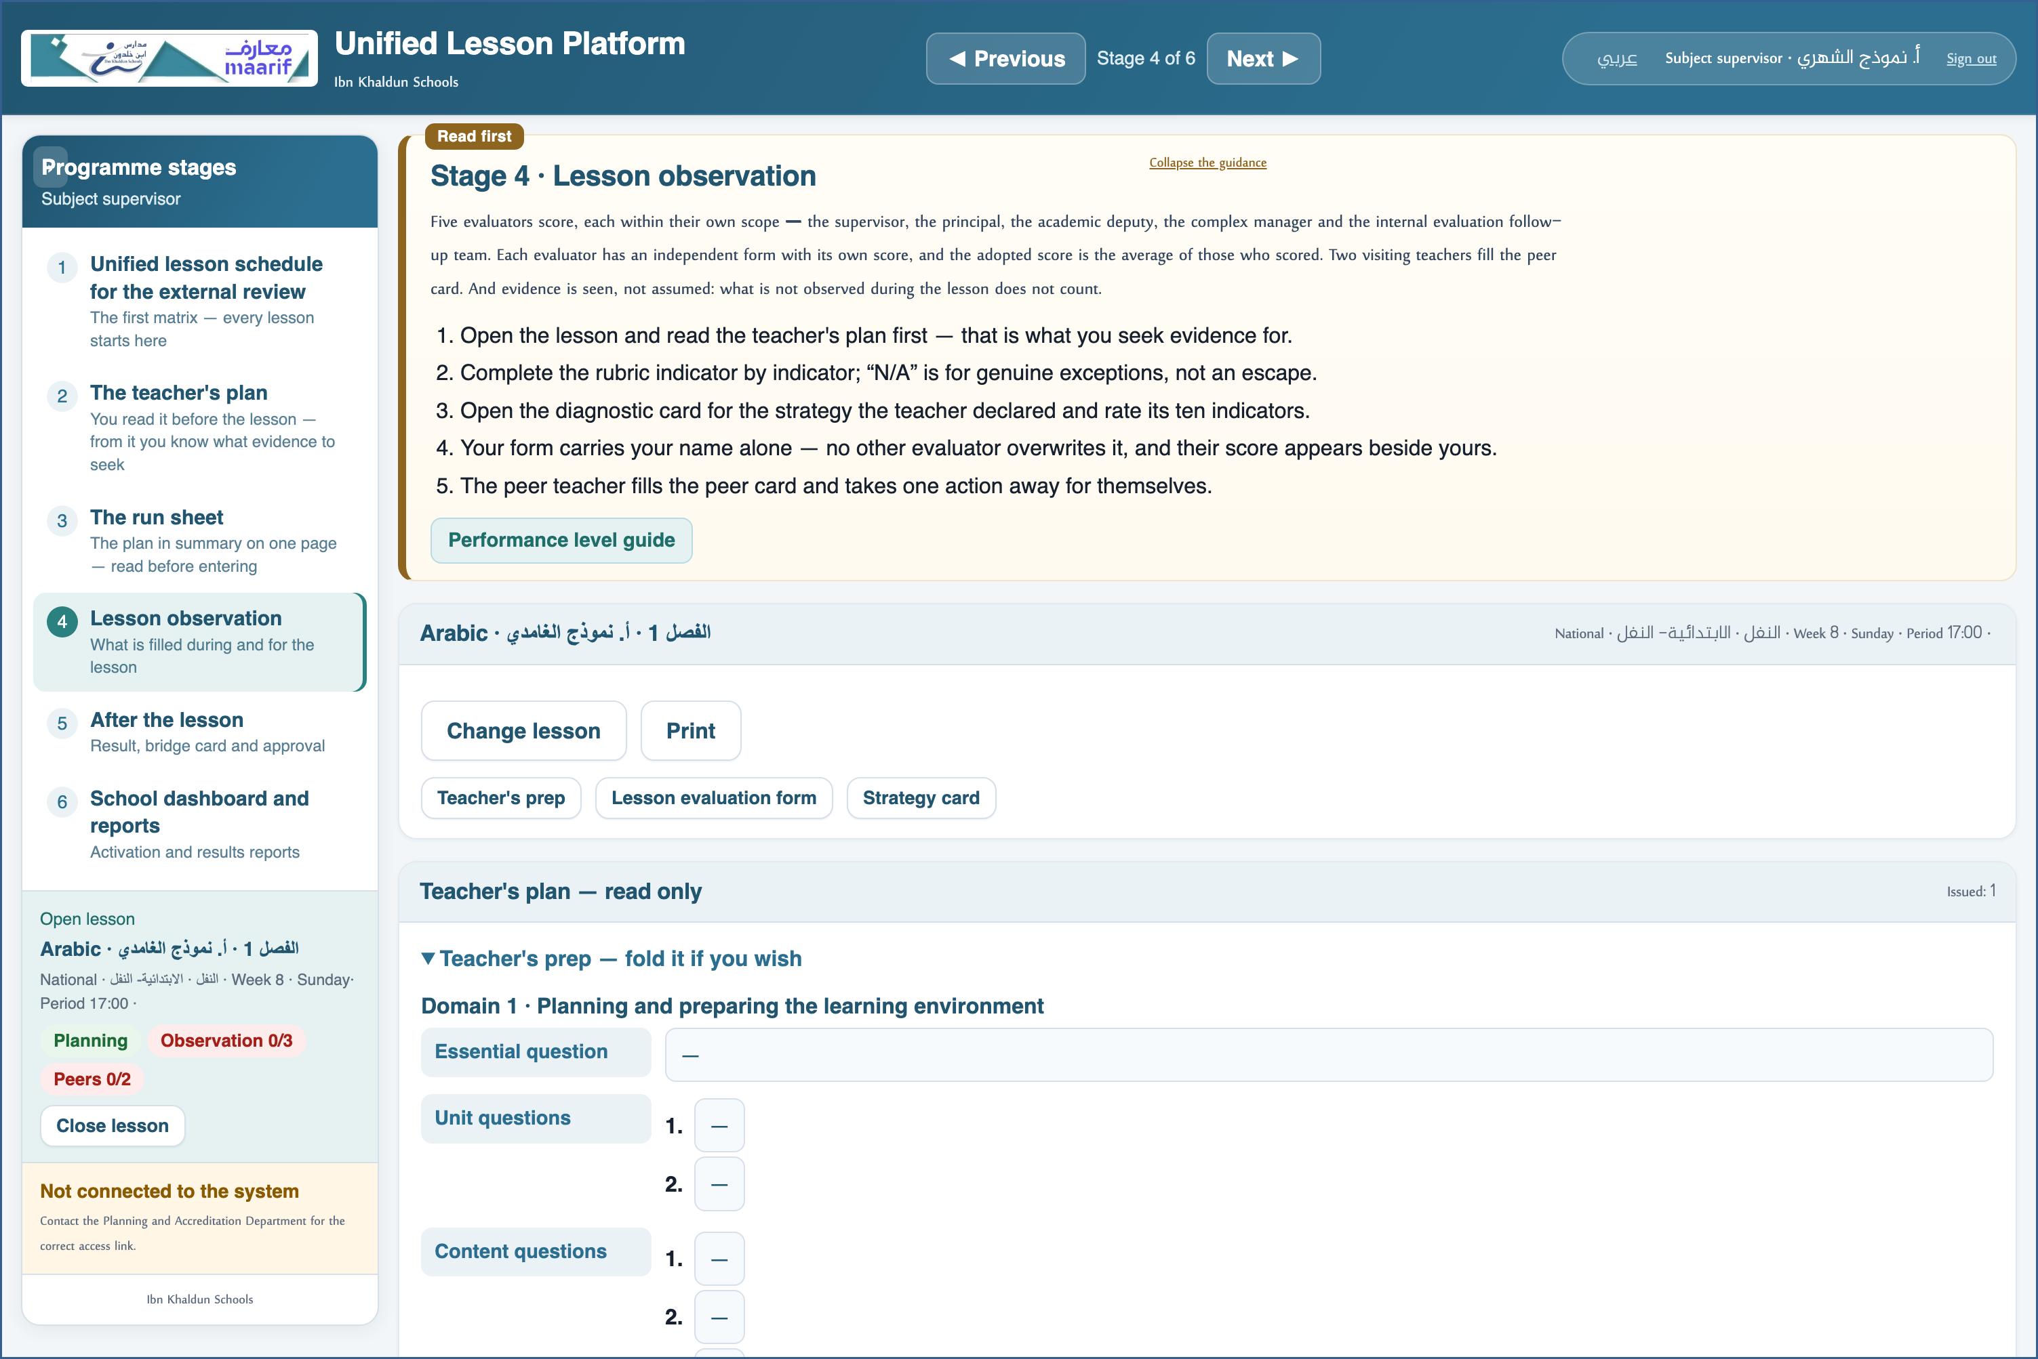
A live screenshot of the platform itself
❖ Where things usually go wrong before you ask — the most common cases
What happens | Why, and what to do
I see many rows that do not concern me | Set the “Subject” filter to your subject and “Day” to your visit day — or press “My visit today”.
I do not see “Assign peers” | Assignment belongs to the academic deputy — it is not in your scope.

❖ Frequently asked
Q: I cover more than one subject — what do I do?
A: The subject filter can be changed at any time from the same screen, without signing out.
Q: Whose lessons do I approve?
A: Those you observed yourself. Approval of a school's lessons is shared with its leadership.
Who to contact
If what concerns you does not appear, or something that is not yours does — contact the Planning and School Accreditation Department.
If the page does not open at all — check the link above and your connection.

https://ahseyam.github.io/unified-lesson/
Planning and School Accreditation Department · Ahmed Seyam

